ASIAN PARLIAMENTARY ASSEMBLY

The Meeting of APA Standing Committee on
Budget and Planning
3 - 5 September 2019
Baghdad, Iraq
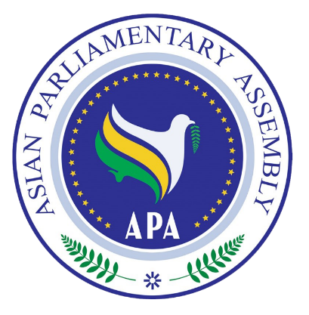 |  | 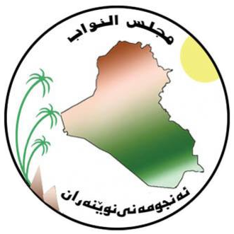

To facilitate the process of ID badges issuance, please complete
and return this form together with the Registration Form
List of Delegation of the country ……………….

No. | First Name | Last Name | Position | Photo

